Senior Project: Quarter 1 Report

# Summary

This report covers the events and contributions that I have personally implemented into the senior project. Introducing ideas and implementing resources and learning new techniques to create the senior project.

## Week 1: Brainstorm and Design

Week 1 I focused on creating a set and stone idea for what the project is going to be. To do this I started a google doc and shared it among the group. From the pre-existing ideas I grouped everything together and used it as a base to see where we could go. I formatted the document to fit as many things as we need in order to have enough to build a project on. From there I came up with concepts for mechanics such as attacks, enemies, and player mechanics. The enemies and player attacks will vary depending on color. Color is something I believe was important to make the game differentiate from other normal dungeon games. In the end, I came up with the idea of a 8-bit boss rush dungeon escape type of game, where the main mechanic revolves around color. In order to add more to the game, I also wanted to incorporate changing rooms, where rooms and dungeons layouts were never going to be the same for replay ability.

Links: <https://docs.google.com/document/d/1DLW6WijsdR3vC6v1ieVei0dyA3mv9H1fZR0htvKCUuE/edit?usp=sharing>

## Week 2: Creating Visual Designs

Week 2 we designed Visual concepts of the game and game behaviors. I introduced the idea of creating the designs on a Figma board. From there I drew up some designs to be used in the Figma Board.

I also created some character models and implemented some characteristics for them. These designs are temporary and are just used as place holders until assets are found.

After I drew some of the user stories that were made by Samuel and put them on the board. When implemented it gave more of a visual idea of that it is that needs to be coded and what needs to be looked into

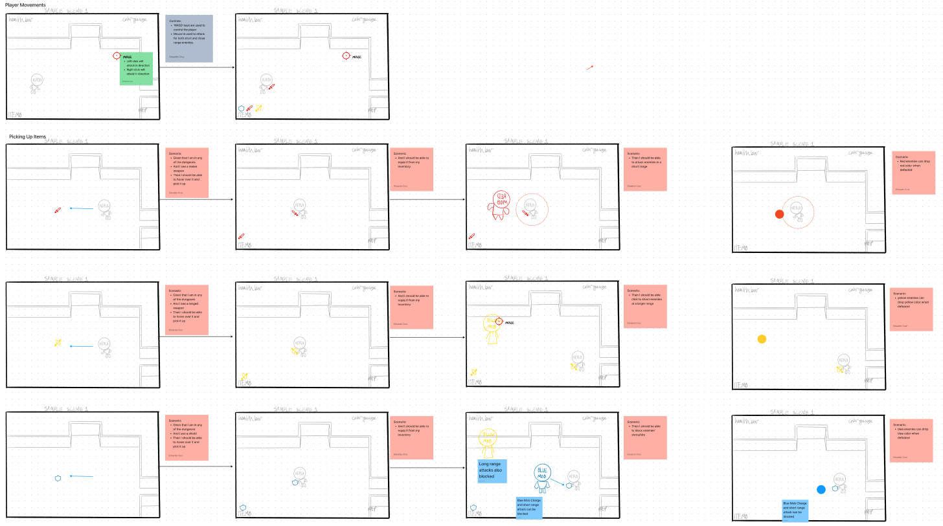

During this week a Jira was also started to begin the next week.

Links: (FIGMA) <https://www.figma.com/file/5jP9fUDDGcZiBtnox7yEaQ/Prism-Drawing-Board?node-id=0%3A1&t=dLKeaNkXsiTwSLQ8-1>,

(JIRA)<https://jrsite.atlassian.net/jira/software/projects/BRP/boards/4/roadmap?shared=&atlOrigin=eyJpIjoiMGEwNzViMTNhMDY5NDYzYWE2YTU0YjI3N2Q4NzJmZTIiLCJwIjoiaiJ9>

## Week 3: Starting the First Sprint

This week the team started the first sprint, I was assigned to start building the player movement and animation. I looked through examples of how to make player movement and implemented what I believe was more efficient within the project.

Link: [PlayerMovement.cs](https://utrgv-my.sharepoint.com/:u:/g/personal/eduardo_cruz03_utrgv_edu/EVqq1F8B9JNOgWhbXqPjbIkBXa5oeHbF2lkvaFGtpofSsQ?e=Nh9HnG)

The animation was very interesting to work with, I used the animator within unity to build the animations, as of right now the assets I am using are not solid and are just being used as reference. Within my own scene I implemented the animation that can be modified to other entities within the map.

Link: [Prism - Player Animation - Walking.mp4](https://utrgv-my.sharepoint.com/:v:/g/personal/eduardo_cruz03_utrgv_edu/ETxycfWUR1tAnuPVeSTohpIBinS4TFkgZoWotC1nLupaqQ?e=Xm6EPh)

## Week 4: Completing First Sprint

The last thing that I made within the quarter was introducing the attacks for the player. I started with the ranged attack and finished making a working attack that revolves around the player using random assets. Two scripts had to be made, one for the projectile and another one for the user.

Link: [RangeAttack.cs](https://utrgv-my.sharepoint.com/:u:/g/personal/eduardo_cruz03_utrgv_edu/Ec4E1jI2tolOkuJQCpjOPiMBv0s70j0uLik7gHq5lAMjlA?e=MjttVF), [ArrowScript.cs](https://utrgv-my.sharepoint.com/:u:/g/personal/eduardo_cruz03_utrgv_edu/EQkqUJUYIVBKjUaRfhgPYrgBlBb_PflKLXcpr2xS4RNkTA?e=0rkhpx)

In order to make the player know where the arrow is shooting The ranged weapon is rotating around the player, when the user clicks it shoots an arrow towards the click. The arrows are being spawned and destroyed in real time and is something that can be changed in order to improve performance. But for the meantime it works as intended and needs the player damage script(property) attached to it.

Link: [Prism - Player Animation - Shooting.mp4](https://utrgv-my.sharepoint.com/:v:/g/personal/eduardo_cruz03_utrgv_edu/EWrTLqrkodRPt0CioPXhzY0BrMPHtXhOrbJzJO6G_aSpZw?e=b7rSqs)

After this I started working on the melee attack and then the shield. These were not completed before the first quarter but will be for the next. The melee attack will either be dependent on the direction the player is facing or similar to the ranged attack where the mouse determines where the user is facing. Another thing that is going to be implemented is when attacking using the ranged weapon the player will pause for a brief moment, meaning the player can not ‘run and gun’